AKASHDIP MAHAPATRA | TECHNICAL PORTFOLIO ADDENDUM
linkedin.com/in/akashdip2001 | github.com/akashdip2001 | akashdipmahapatra.official@gmail.com

ENTERPRISE SYSTEM ARCHITECTURE
Project: ODIE Serverless Data Pipeline (Aerospace IoT & Telemetry)
Role: Data Engineer / DevOps & Infrastructure Maintainer
Scale: Production-grade, high-throughput, multi-tiered AWS serverless architecture processing continuous real-time aviation telemetry and IoT data.
System Architecture Overview:
The system is a decoupled, event-driven data lake consisting of distinct ingestion, processing, storage, and distribution layers.
- Ingestion: High throughput streaming via Amazon MSK (Kafka) and AWS IoT Core.
- Routing: Heavy utilization of Amazon EventBridge to trigger asynchronous workflows based on object creation in S3 Raw Zones.
- Compute: Python-based transformation logic running in containerized AWS Lambda functions (managed via ECR).
- Storage & Distribution: Tiered S3 Data Lake (Raw, Processed, Curated), DynamoDB for real-time state management, and Amazon SNS / Kinesis Firehose for downstream data distribution.
Key Engineering Responsibilities:
- CI/CD Pipeline Ownership: Maintain highly structured GitHub Actions workflows (lambda-container-build-dev.yaml, terraform-release.yaml) handling the end-to-end build, testing, and deployment of Dockerized Lambda functions and Terraform modules across Dev, QA, UAT, and Prod environments.
- Infrastructure as Code (IaC): Manage complex infrastructure using modular Terraform, defining VPCs, IAM roles with strict least-privilege policies, S3 event triggers, and Lambda resource provisioning.
- Container Security & Maintenance: Monitor Dockerfiles and requirements.txt dependencies across multiple microservices (e.g., AIDX Sequencer, Aircraft Towing Processor, GSE Tracking), actively identifying and patching CVEs to maintain strict enterprise security standards.
- Observability & Troubleshooting: Utilize AWS CloudWatch and Datadog for system-wide tracing, log aggregation, and error handling (managing Dead Letter Queues) to ensure zero data loss in the ingestion layer.

Hardware & Academic Engineering
APPLIED NETWORKING & IOT ENGINEERING (Selected Projects)
1. Network Attached Storage (NAS) & Custom Web Hosting via ESP32
- Tech Stack: ESP32, Arduino, HTTP, Local Area Network (LAN).
- Details: Engineered a microcontroller-based NAS to serve files over Wi-Fi. Extended this architecture to host a custom HTML web interface directly on the ESP32 for localized hardware control, simulating a micro web server environment.
2. Wi-Fi Penetration & Network Security Tool
- Tech Stack: ESP8266/ESP32, Python, Packet Sniffing.
- Details: Designed a wireless network testing system capable of scanning 802.11 traffic, capturing handshake packets, and broadcasting de-authentication packets to test network access point vulnerabilities.
3. Real-Time GPS Tracking & Telemetry System
- Tech Stack: Node.js, Express, Socket.IO, ESP32, GPS Modules.
- Details: Built an end-to-end IoT telemetry pipeline. Captured live GPS coordinates on edge hardware (ESP32) and streamed the data via WebSockets to a Node.js backend for real-time mobile visualization.
4. Lightweight Python Web Server (From Scratch)
- Tech Stack: Python, TCP Sockets, OSI Model Layer 4/7.
- Details: Bypassed standard frameworks (like Flask/Django) to build a raw HTTP server using basic Python TCP socket programming. Handled low-level GET/POST request parsing and static content delivery to solidify core networking fundamentals.

PROFESSIONAL CREDENTIALS & CERTIFICATIONS

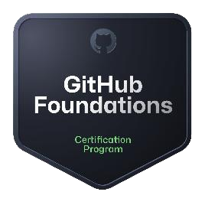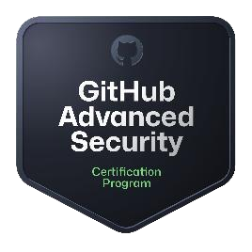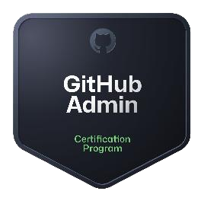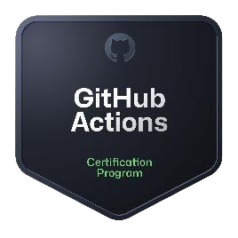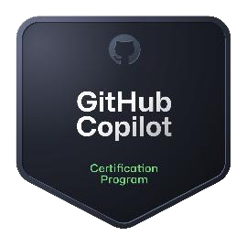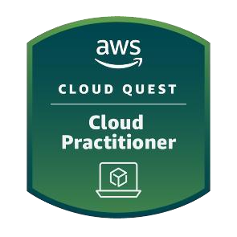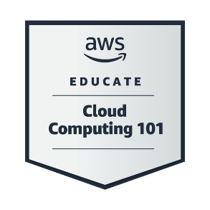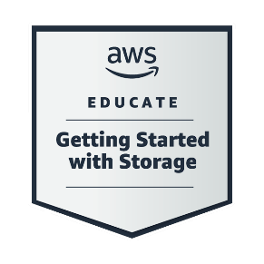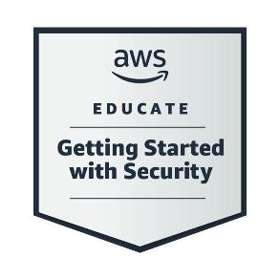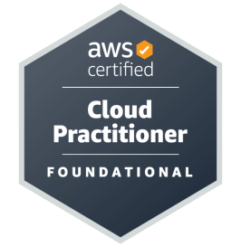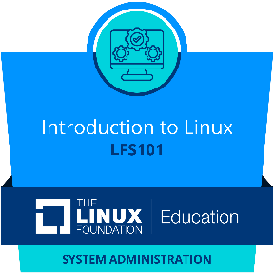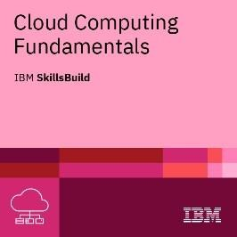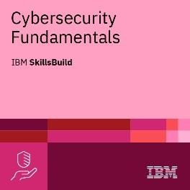

Verify in Credly - https://www.credly.com/users/akashdip2001/
